Arctic Wolf Assignment Server / Client Application Setup

1. Setting up Server Application
   1. After cloning the Server Application repository, open IntelliJ IDEA and open the folder containing the Server Application and select pom.xml.

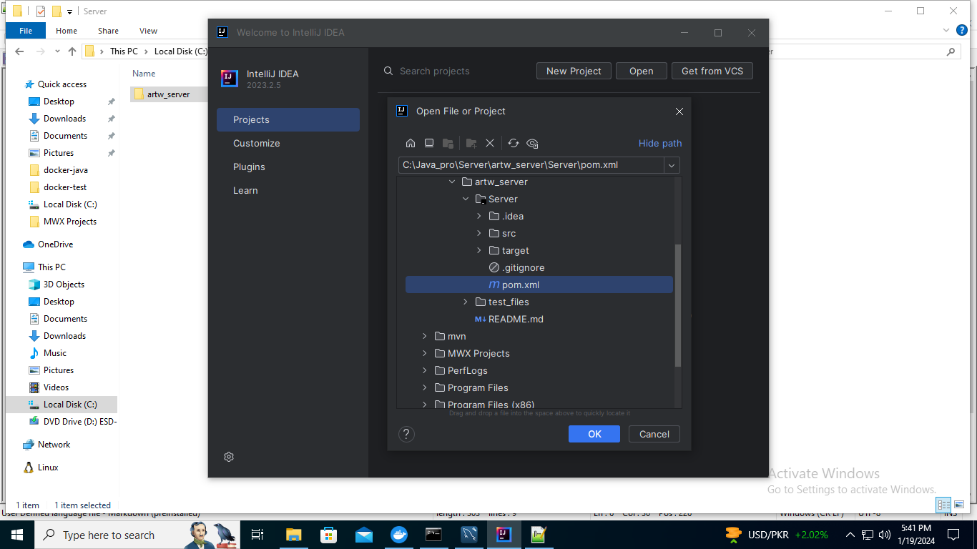

* 1. Next click ‘Open as project’ and next ‘Trust Project’
  2. Project will open, now clean and build the project.
  3. Create a folder ‘C:\FileServer\Processed’ and place app.config file in newly created from the ‘test_files’ folder which is in the git cloned folder.
  4. Click on the Current File then Edit Configuration

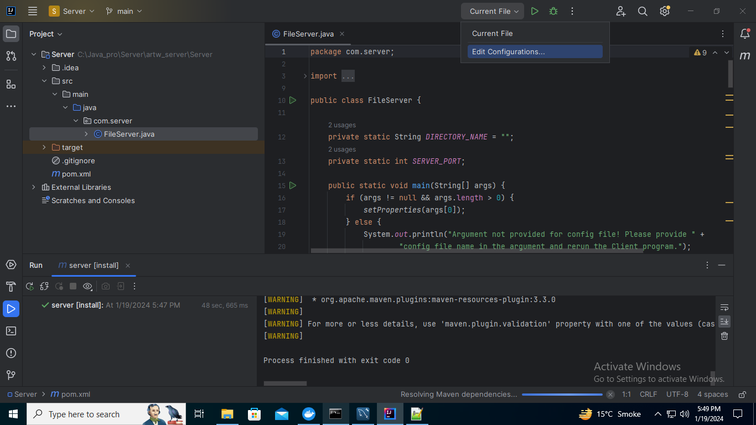

* 1. Click ‘add new’ and then click ‘application’

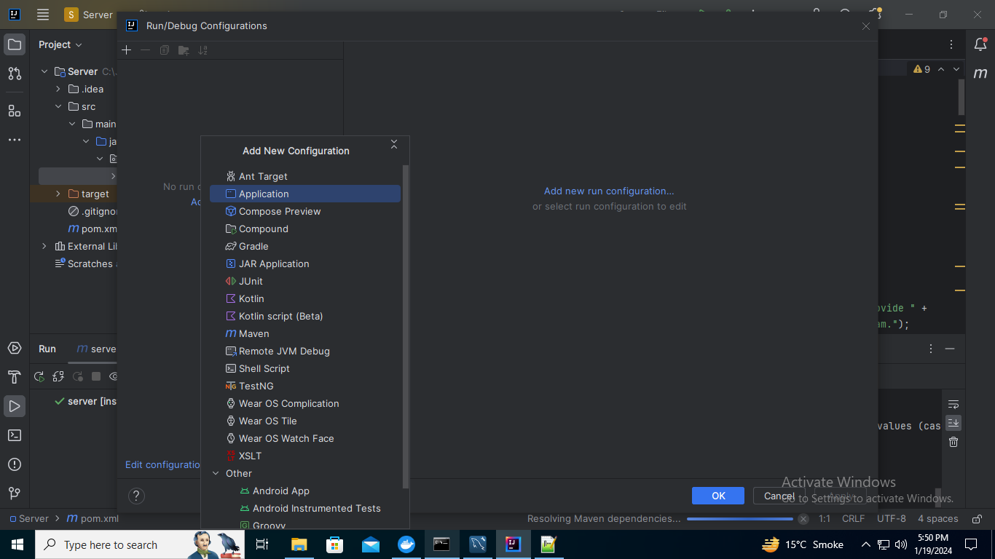

* 1. Provide the name of configuration and in Program Argument field enter ‘C:\FileServer\Processed\app.config’
  2. Select the Main Class (com.server.FileServer)

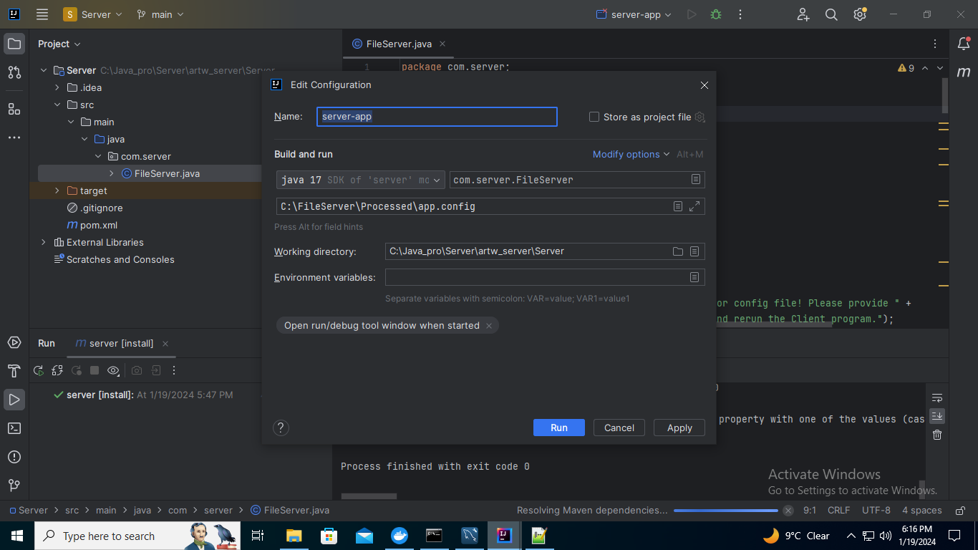

* 1. Run the application

1. Setup the Client Application
   1. After cloning the Client Application repository, open IntelliJ IDEA and open the folder containing the Client Application and select pom.xml.
   2. Next click ‘Open as project’ and next ‘Trust Project’
   3. Project will open, now clean and build the project.
   4. Create a folder ‘C:\FileServer’ and place app.config file in newly created from the ‘test_files’ folder which is in the git cloned folder.
   5. Click on the Current File then Edit Configuration
   6. Click ‘add new’ and then click ‘application’



* 1. Provide the name of configuration and in Program Argument field enter ‘C:\FileServer\ app.config’
  2. Run the application.

1. Running Applications
   1. Server Application

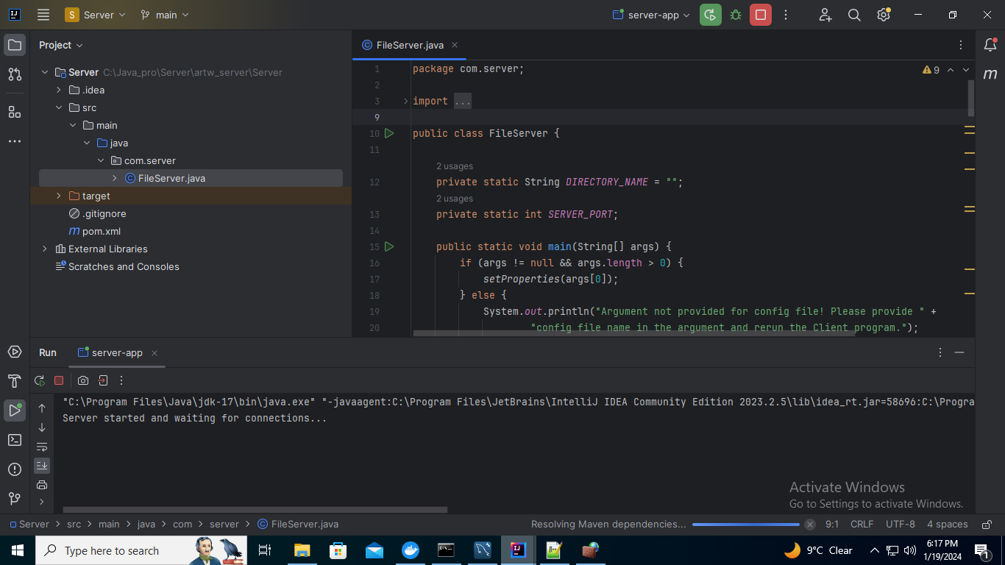

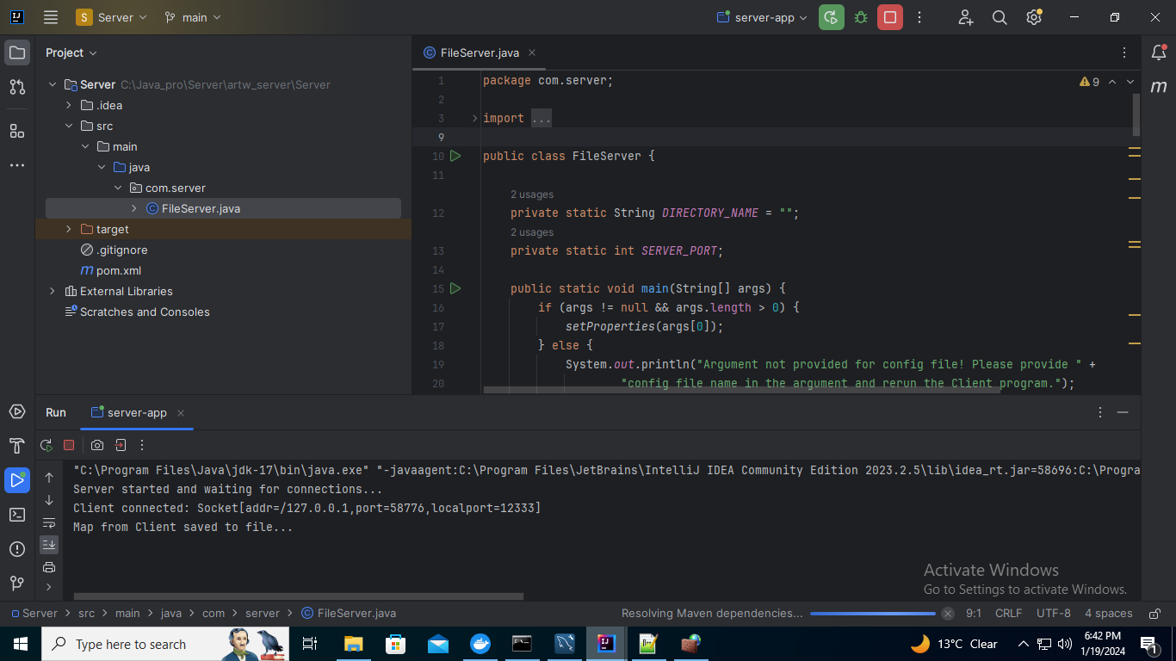

* 1. Client Application

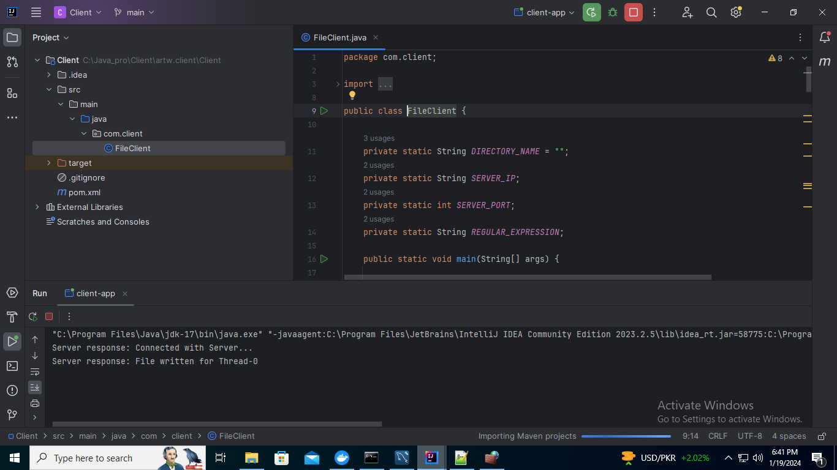

Client application will keep on looking for new files which appear in the folder after 30 seconds.

